Q4. FUNCTION MODULES:

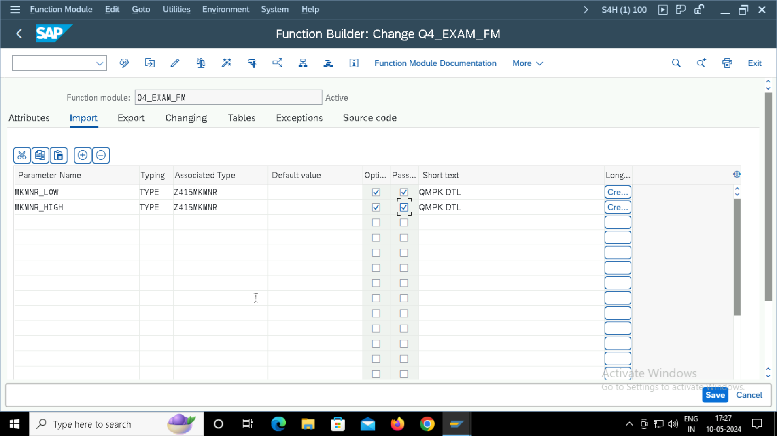

PROGRAM CODE:

Q4.

REPORT Z415_EXAM_FMCODE.  
  
LOAD-OF-PROGRAM.  
  
DATA: LV_MKMNR TYPE Z415MKMNR,  
      IT_TAB TYPE STANDARD TABLE OF Z415_EXAMSTRUCTURE,  
      WA_TAB TYPE Z415_EXAMSTRUCTURE.  
  
SELECT-OPTIONS s_mkmnr FOR lv_mkmnr.  
  
  
START-OF-SELECTION.  
  
CALL FUNCTION 'Q4_EXAM_FM'  
 EXPORTING  
   MKMNR_LOW        = S_MKMNR-LOW  
   MKMNR_HIGH       = S_MKMNR-HIGH  
  TABLES  
    gt_tab          = IT_TAB  
          .  
  
END-OF-SELECTION.  
LOOP AT IT_TAB INTO WA_TAB.  
  WRITE:/ wa_tab-mkmnr,  
  wa_tab-version,  
  wa_tab-pmethode,  
  wa_tab-auswmenge1.  
  
ENDLOOP.